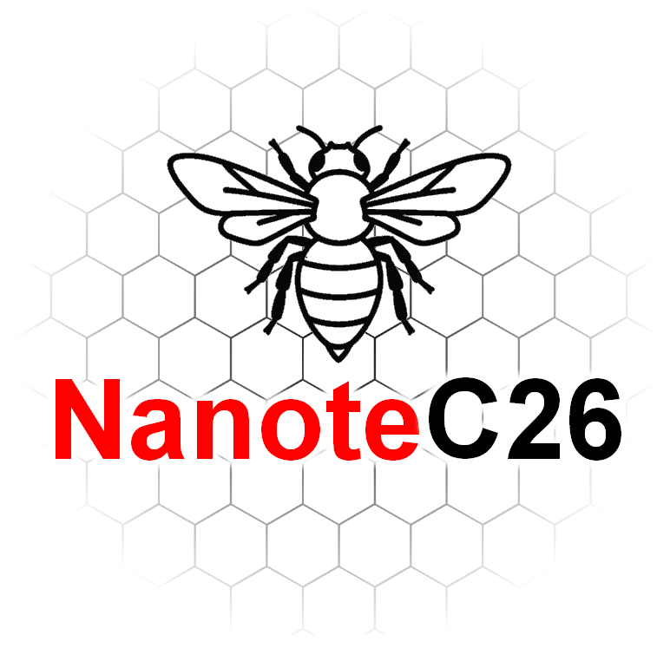
BOOK OF ABSTRACTS
NanoteC26
1-4 September 2026 | Manchester

Tuesday 1 September 2026
Time | Speaker | Talk title
09:30 | Mark Newton | Vacancy, nitrogen-vacancy and vacancy cluster production by low energy electron irradiation and annealing in intrinsic and nitrogen doped diamond
10:15 | Kenny Jolley | Strain-Driven Defects and Ripple Networks in Layered Two-Dimensional Materials: From Atomistic Mechanisms to Mesoscale Behaviour
10:45 | Aline Amorim Graf | Nanosheet size distribution characterisation by optical microscopy
11:35 | Jack Armitage | What Lies Beneath the Surface: Understanding Surface Area and Porosity in Nanocarbons
11:55 | Callum Wood | Atomistic modelling of porous carbons: A joint computational and experimental approach to understanding the nanostructure of F400
12:15 | Beren Dempsey | Tuning Spin Polarisation in Symmetric Graphene Nanoribbons
14:00 | Alan Dalton | TBC - NO ABSTRACT AVAILABLE
14:30 | Peter Lynch | Near-infrared electrochromism on reflective single-walled and multiwalled carbon nanotube electrochromic devices
14:50 | Bo Peng | Fullerene quantum magnets from first principles
15:20 | Dilara Ickecan | Local Atomic Environments to Phonons: Machine Learning Potentials for Low-Dimensional Carbon Nanostructures
16:10 | Chris Ewels | Nanoscale Modelling of Carbon Defects
16:40 | Daria Nasartdinova | Computational study of dislocations and ripples in bilayer graphene and hexagonal boron nitride
Abstracts follow in the same running order.

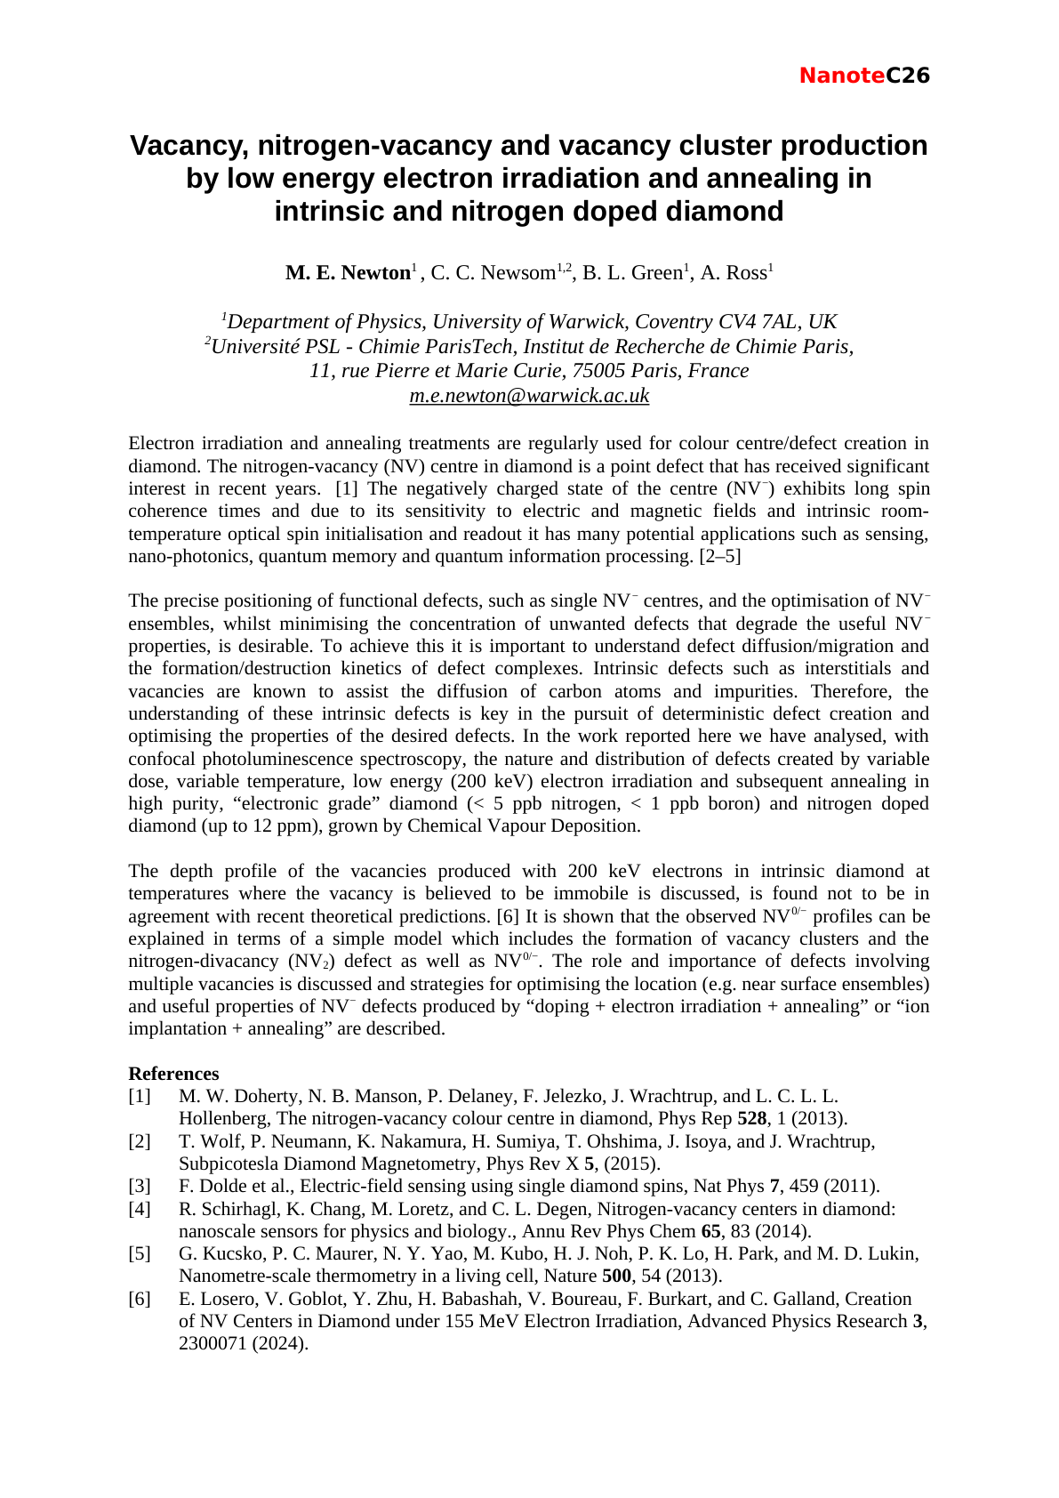

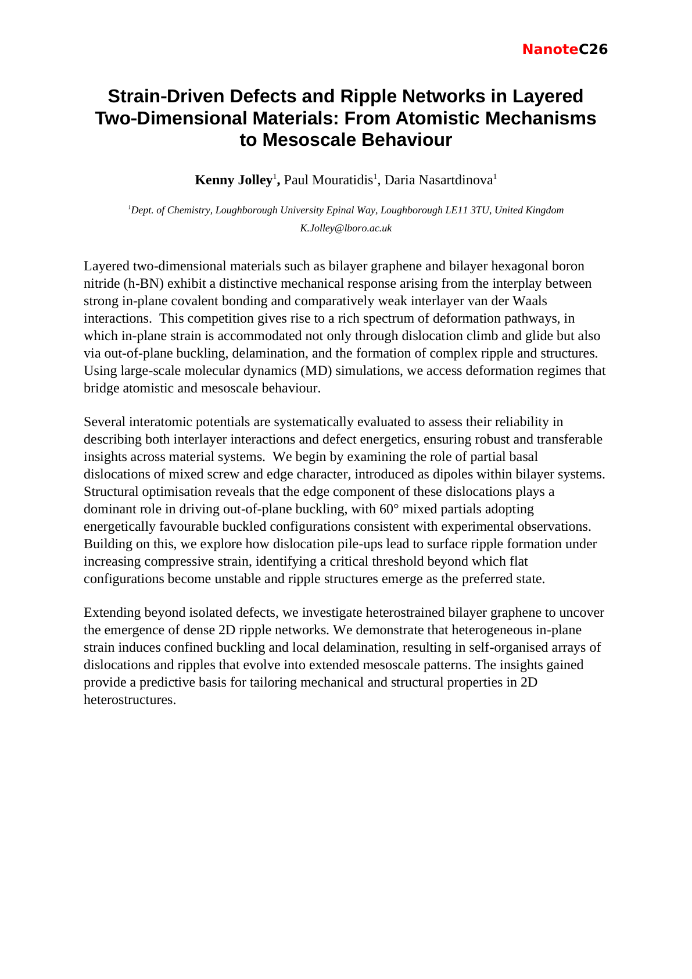

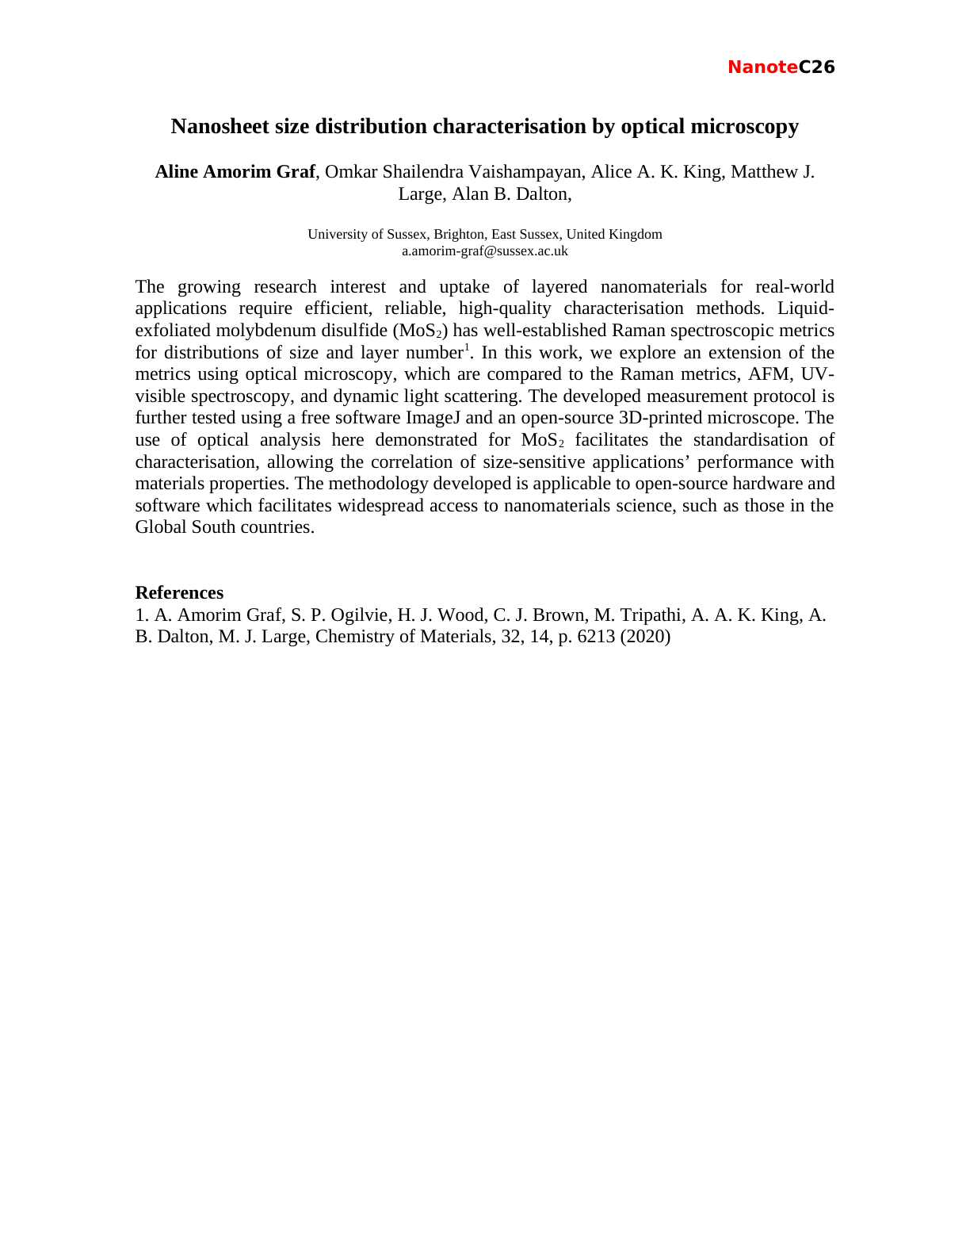

What Lies Beneath the Surface: Understanding Surface Area and Porosity in Nanocarbons
Jack Armitage
Verder Scientific
Nanocarbon performance is strongly influenced by surface area, porosity and surface chemistry. Gas adsorption provides a powerful way to measure these properties and reveal structural differences that particle size alone cannot explain.
This presentation explores the fundamentals of gas adsorption, the importance of accurate free-space measurement, and the interpretation of BET surface area and pore-size data. Using examples including carbon black and carbon nanotubes, it highlights how advanced analysis methods can provide deeper insight into complex micro- and mesoporous carbon structures.

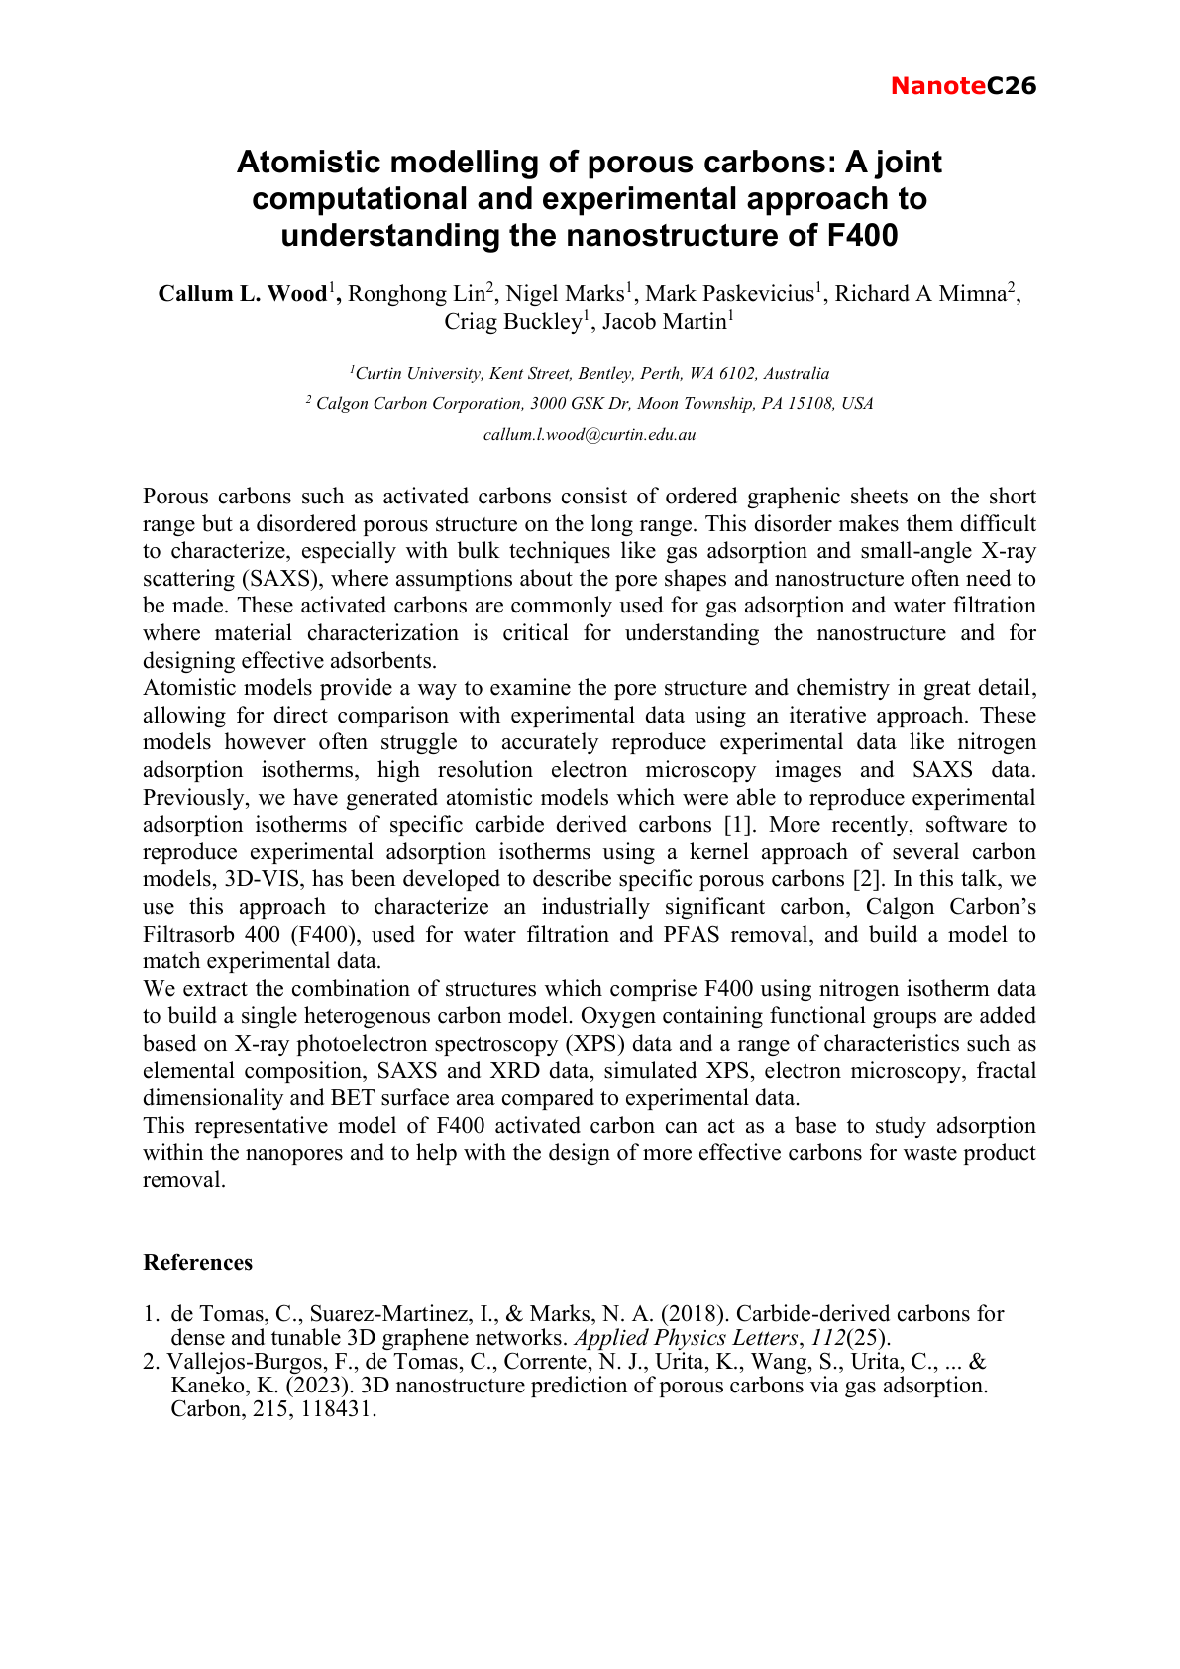

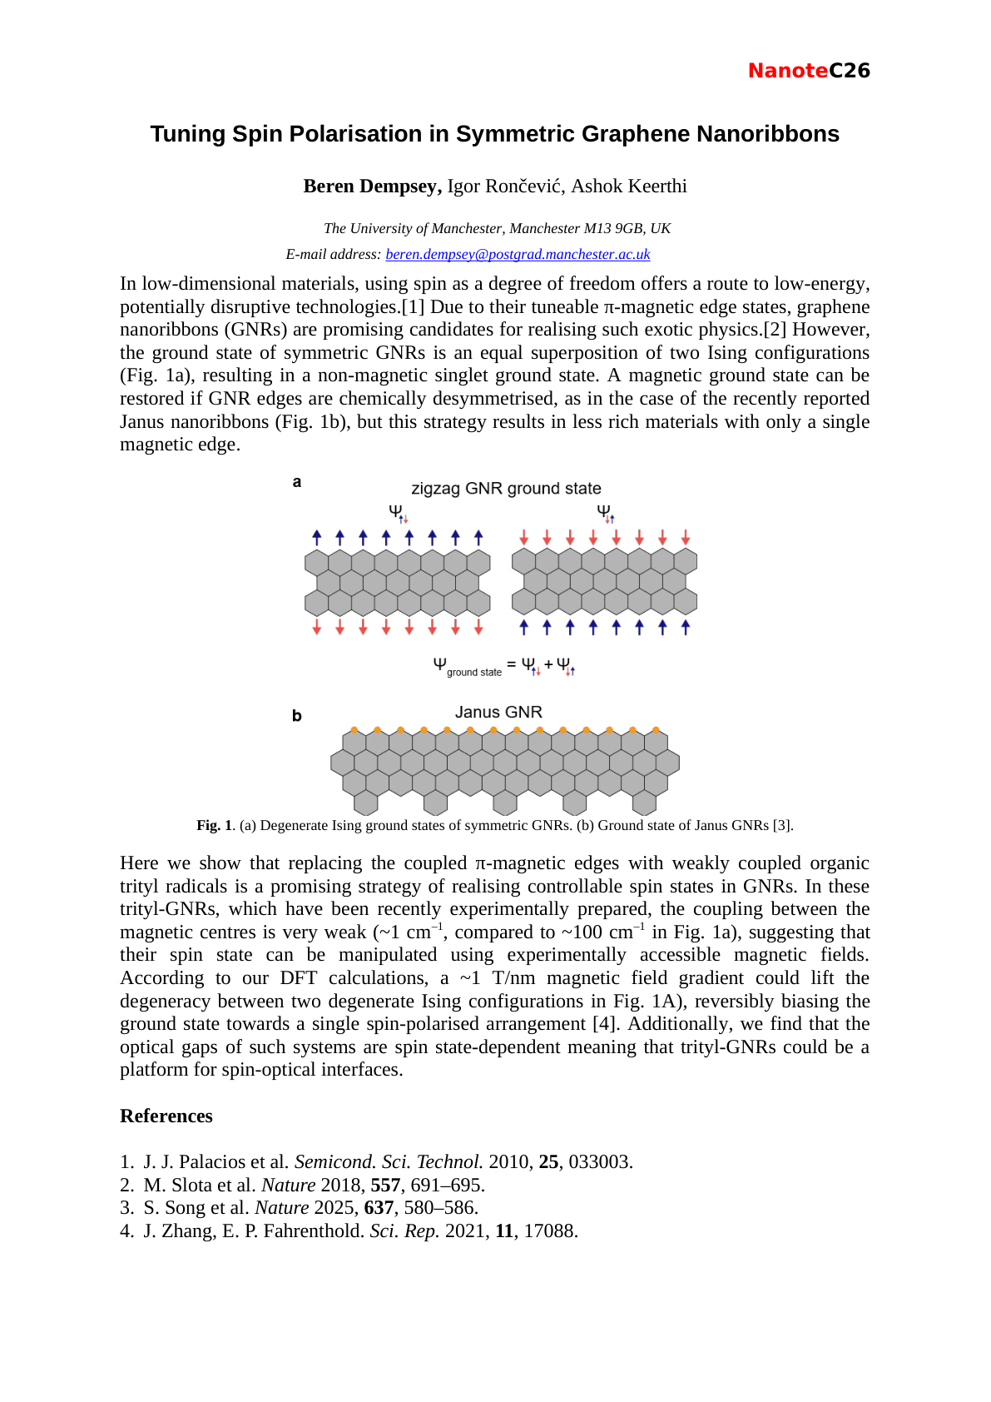

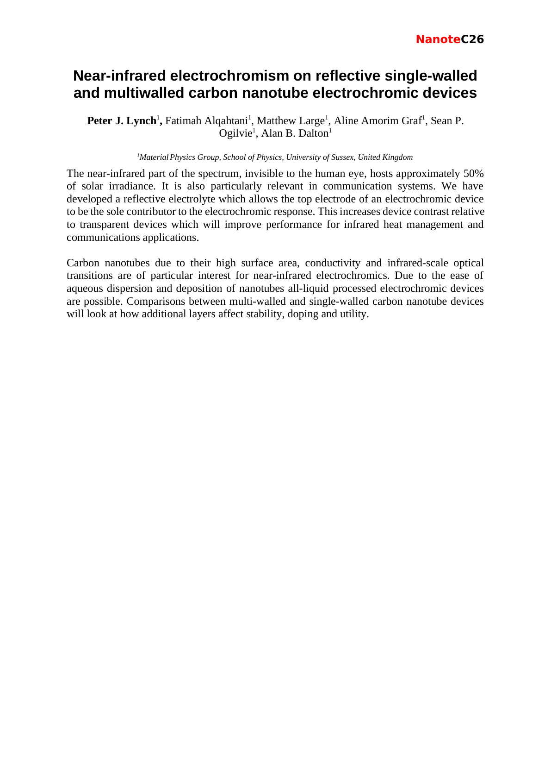

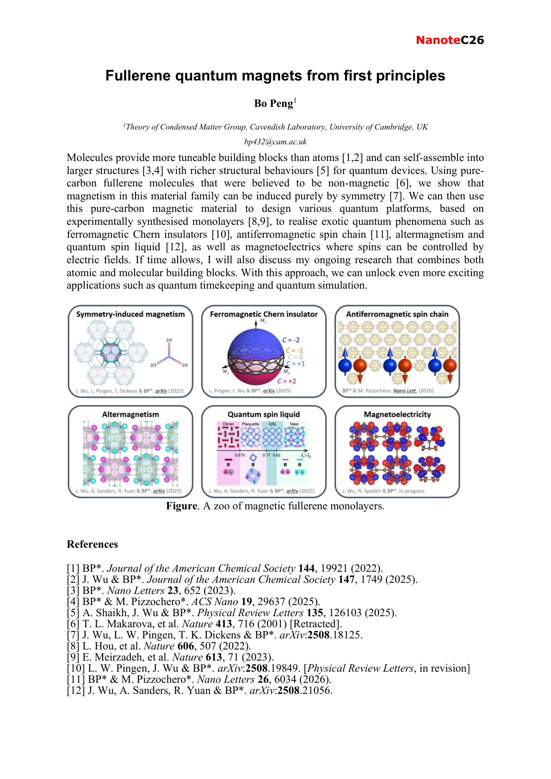

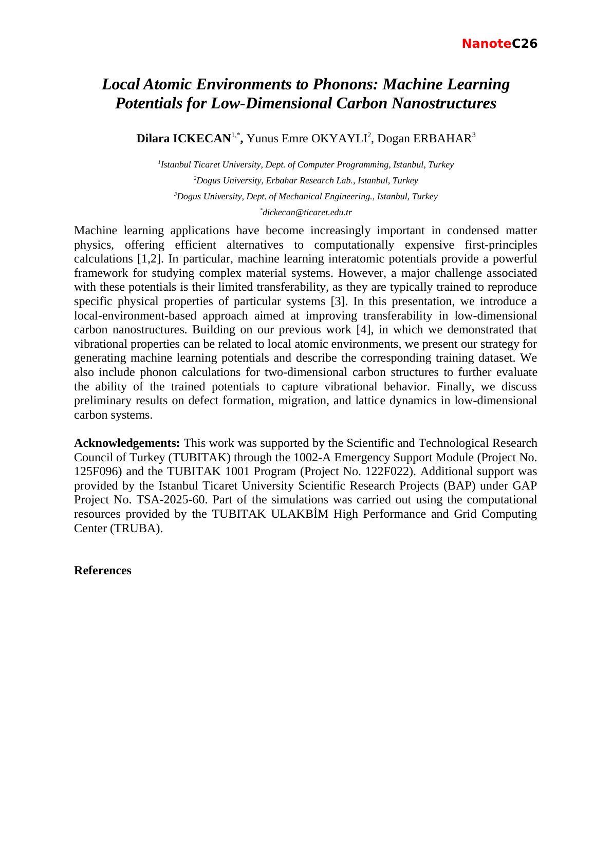



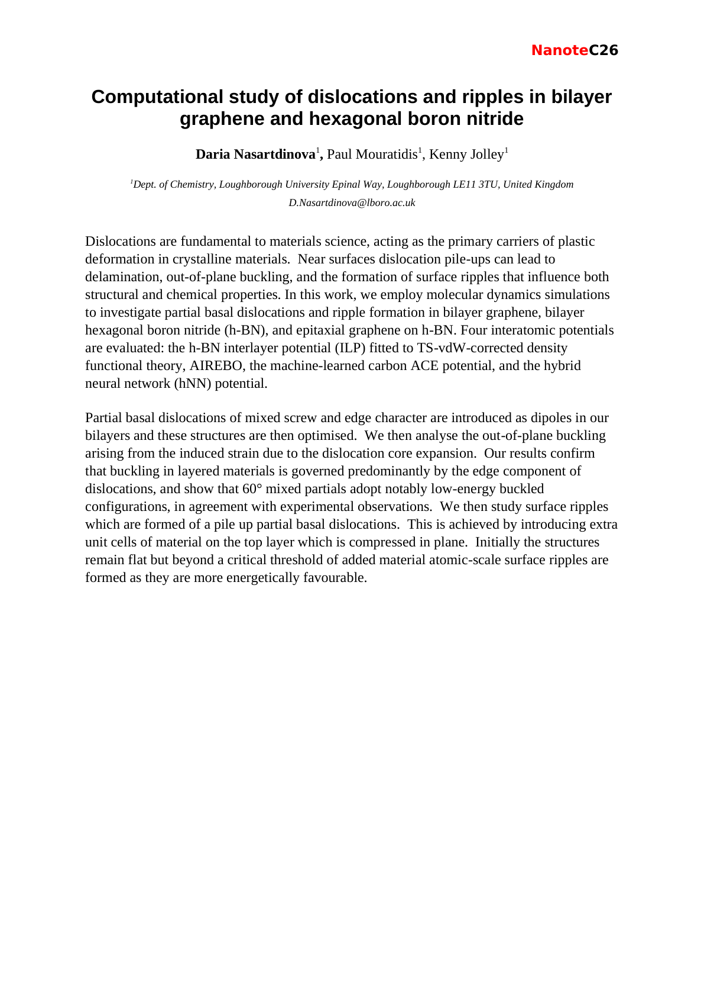

Wednesday 2 September 2026
Time | Speaker | Talk title
09:00 | Elton Santos | Pushing the limits of magnetism towards energy-efficient applications
09:45 | Jason Stafford | Vibrational synthesis of 2D materials
10:05 | Ke Hu | Development of Vitrimer/GNPs Coatings for Corrosion Protection of Magnesium Alloy
10:25 | Varvara Bolikava | Transient Cellulose Stabilisation Enables Tap-Water Production of Graphene Nanosheet Inks from Electronic Waste
11:15 | Geoff Fowler | The drivers and challenges of recovering and recycling amorphous nano carbons from rubber
11:45 | Sumudu Adikaram | Investigating the Trade-off between Conduction and Convection in Graphene-Enhanced Phase Change Materials
12:05 | Paul Mouratidis | Emergent Ripplocation Networks in Heterostrained Bilayer Graphene
14:00 | Cinzia Casiraghi | Printable Electronics enabled by Supramolecular 2D Material Inks
14:30 | Matthew Large | Emissivity of conducting thin films
14:50 | Johan Vandenborre | When Radiation Chemistry, Photo-Chemistry and Sono-Chemistry meet, what is their Topic? Fricke Chemistry!
15:10 | Conor Boland | The Secret Social Life of Nanosheets in a Centrifuge
16:00 | Toby Squire | Electrically Conductive Adhesives Based On Nanomaterials For Effective And Sustainable Joule CFRPs Bonding And Selective Debonding
16:20 | Yuru Liu | Flash Reduction of Graphene Oxide-Alginate Films towards Conductive Composite Networks
16:40 | Joseph Owen | Rationally Designed Battery Electrodes
Abstracts follow in the same running order.

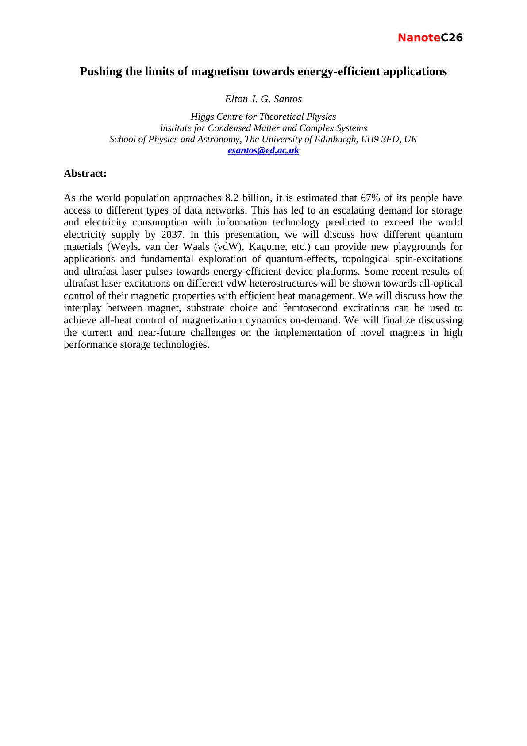

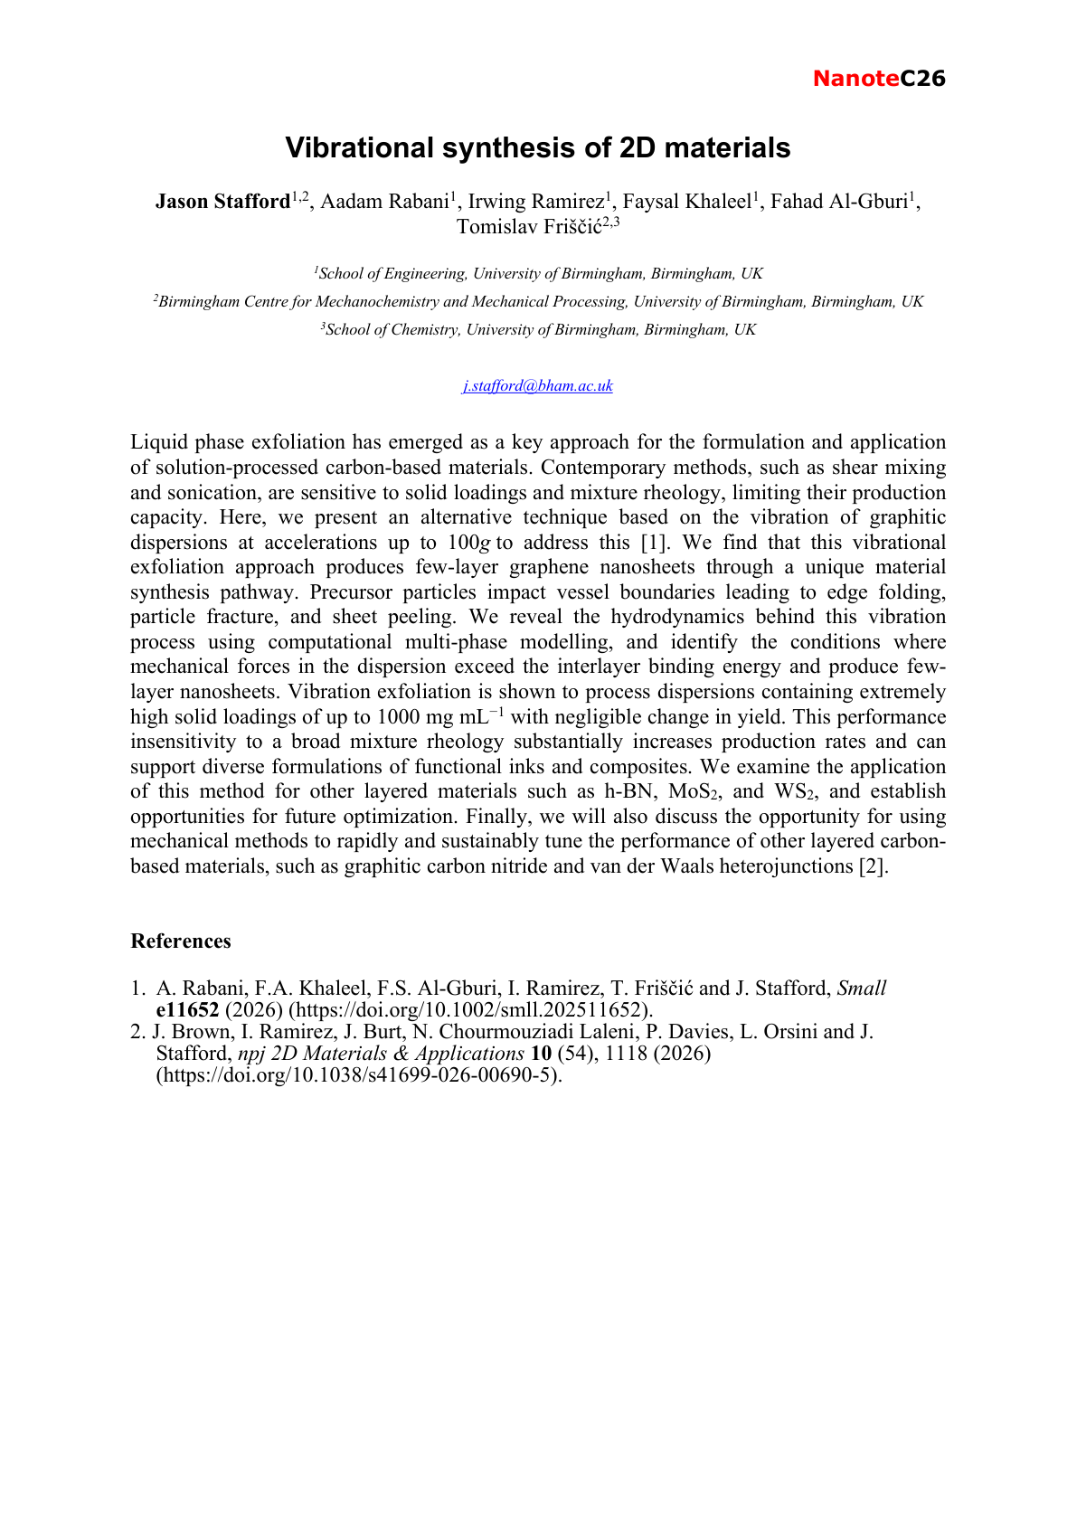

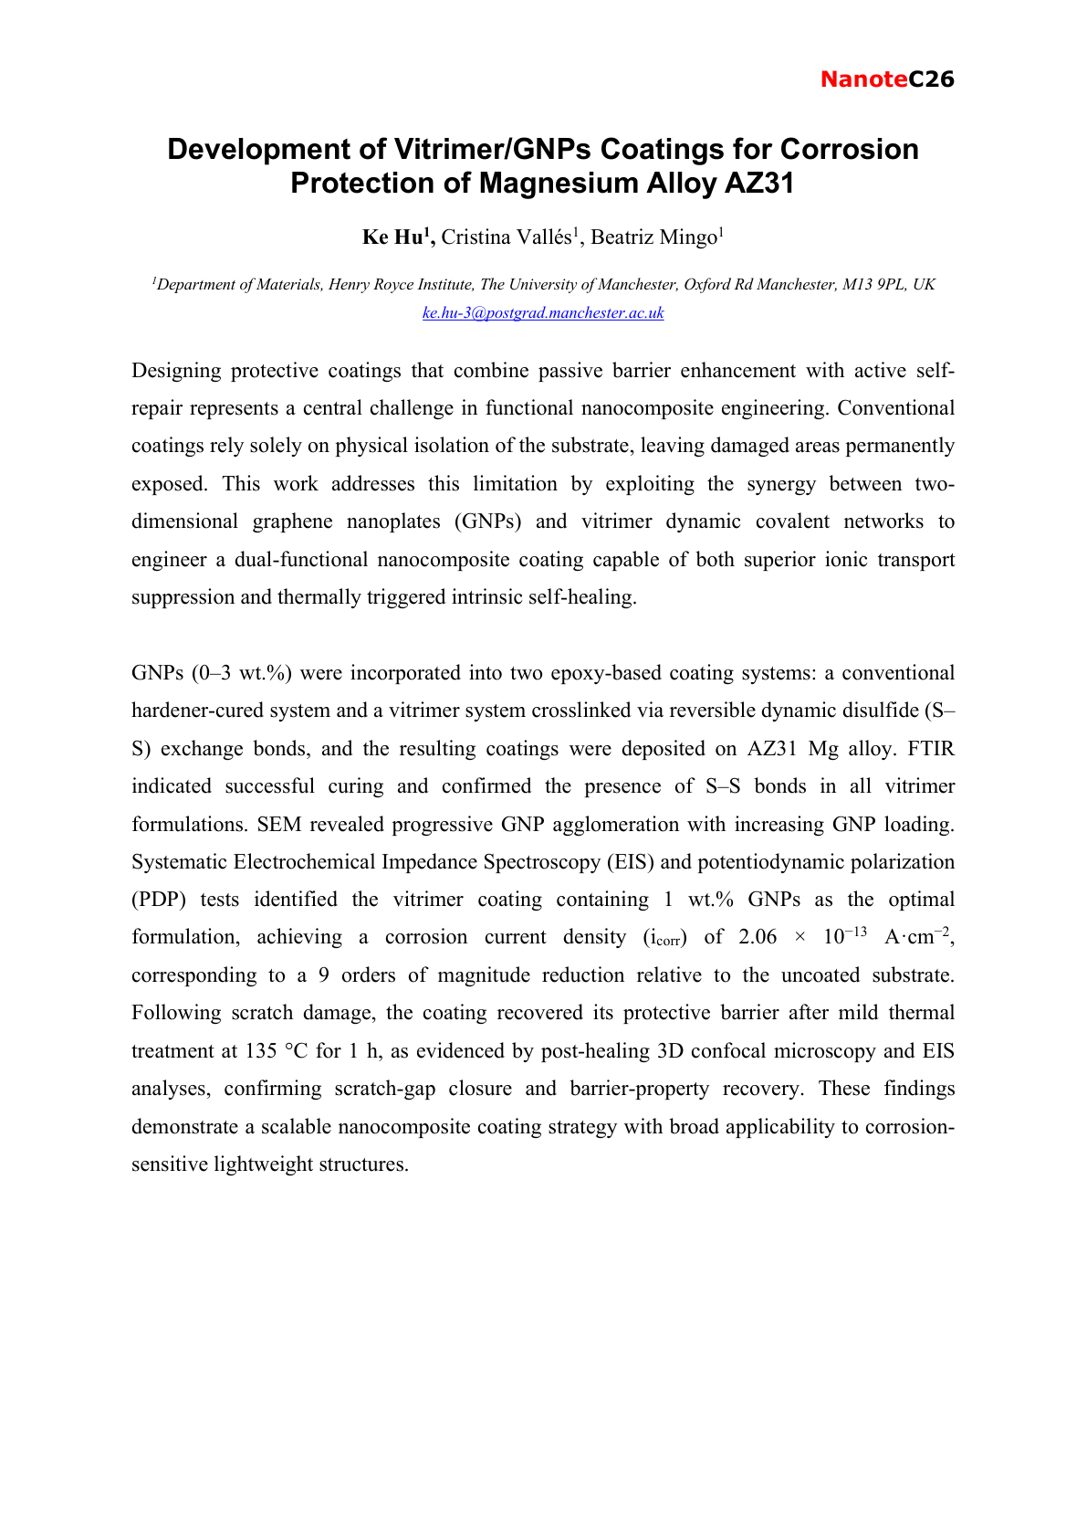

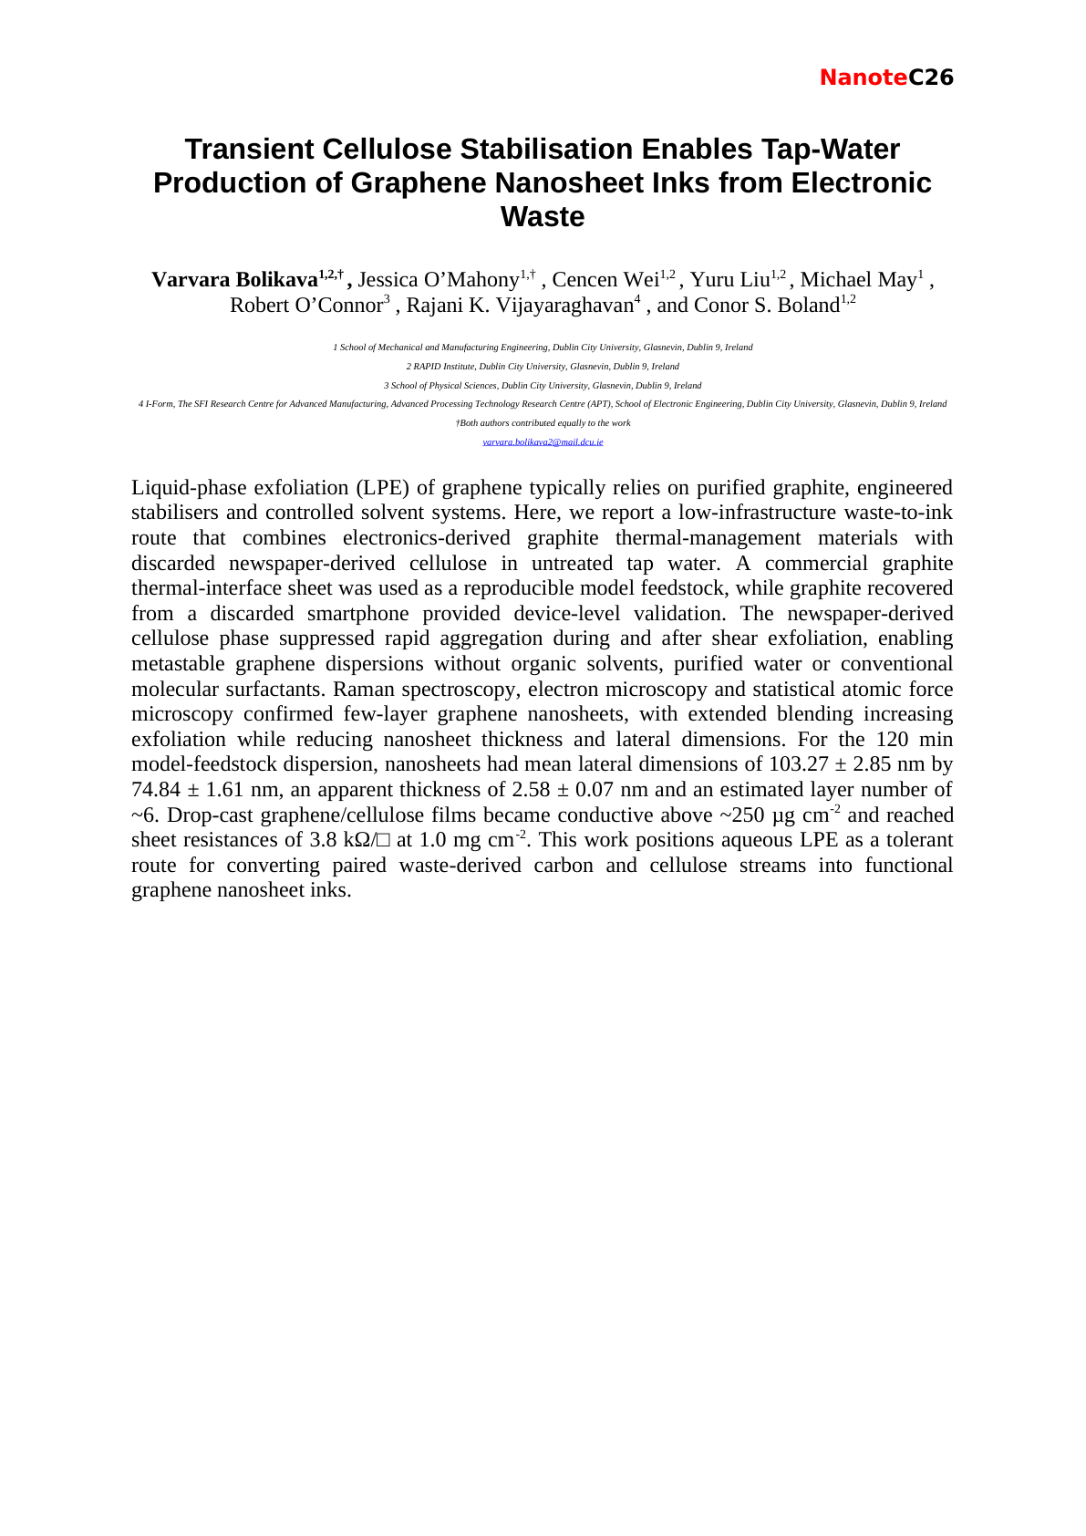

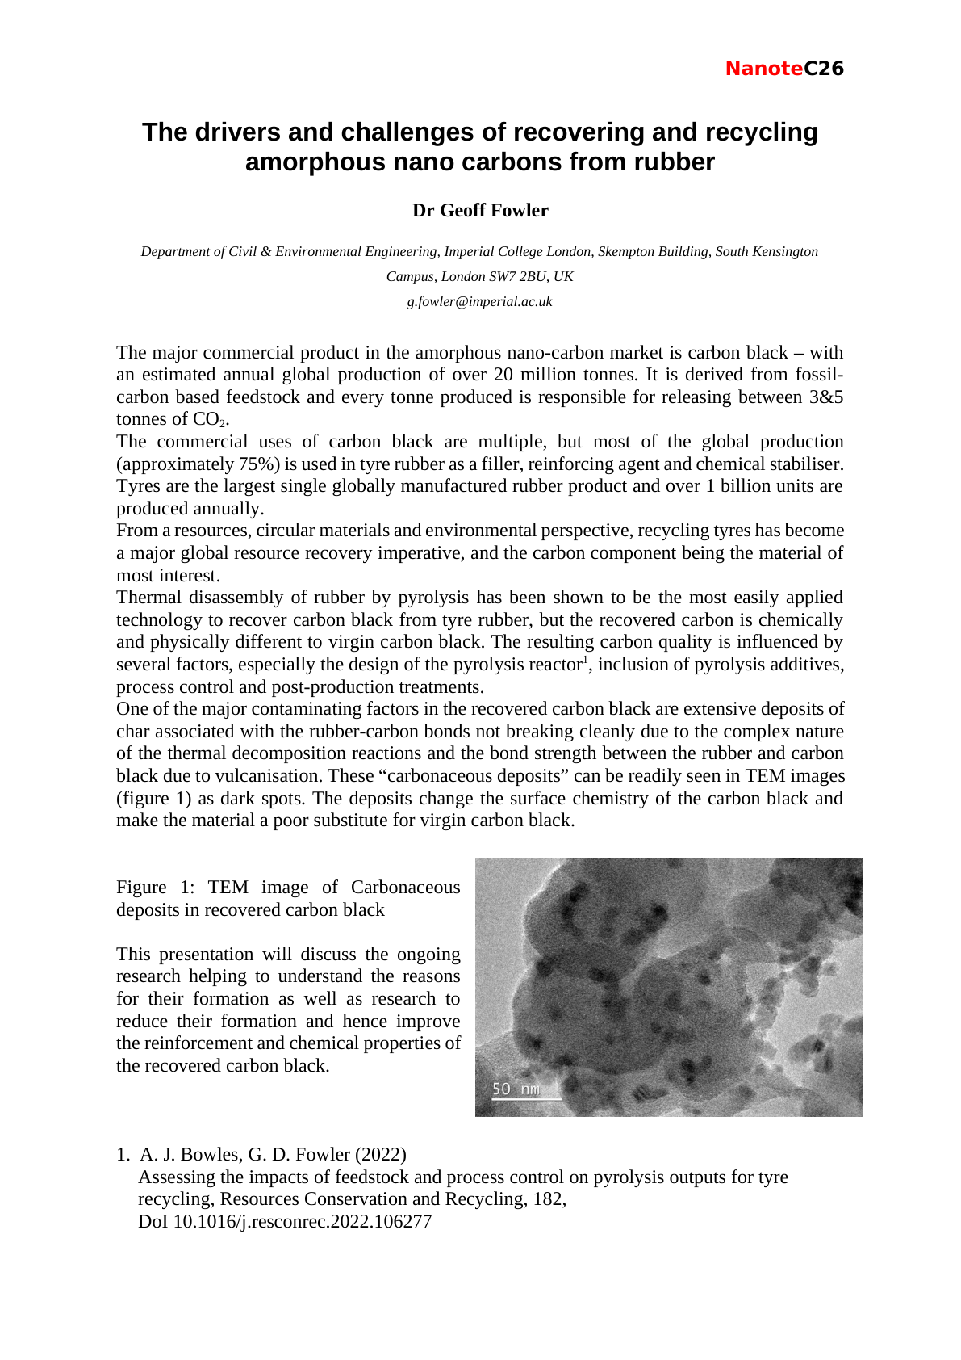

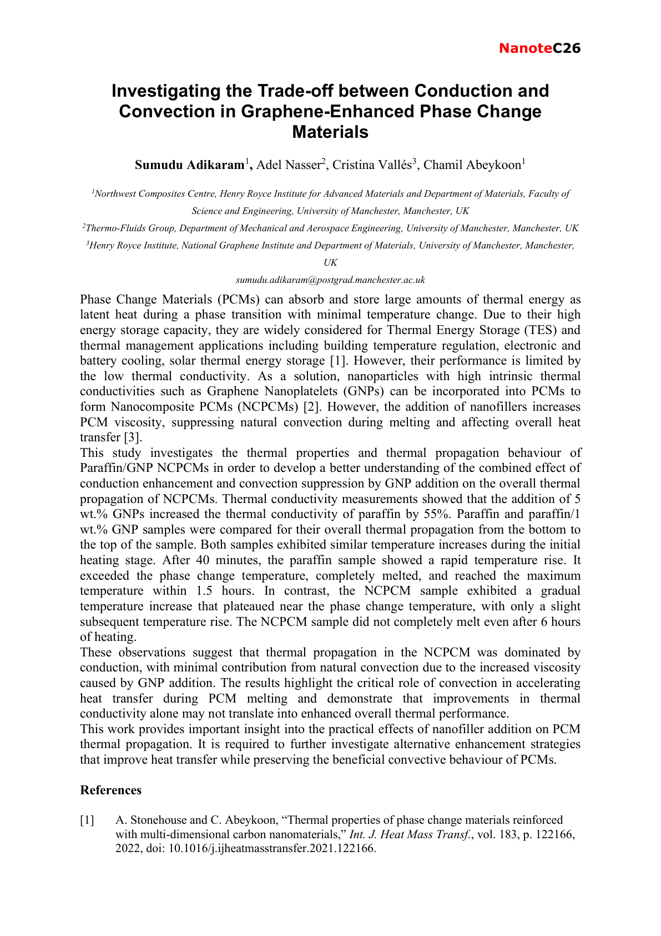



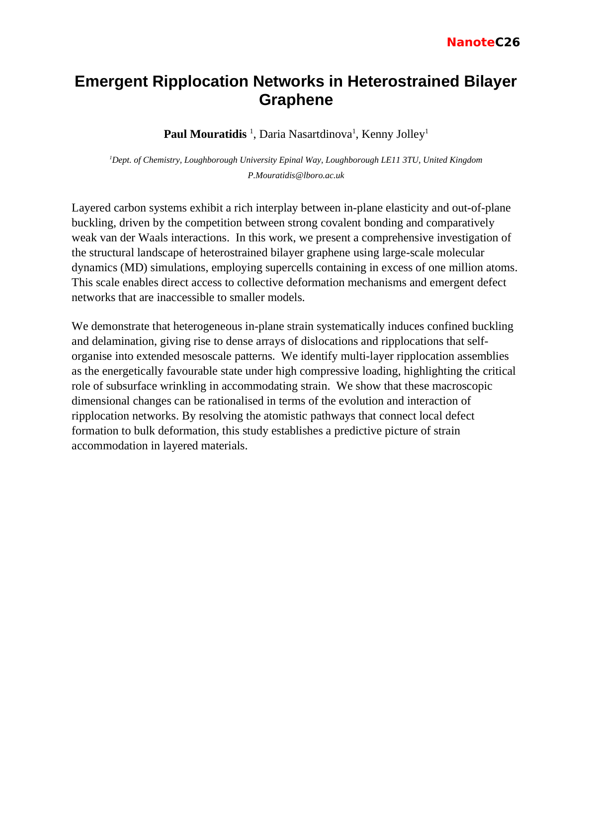

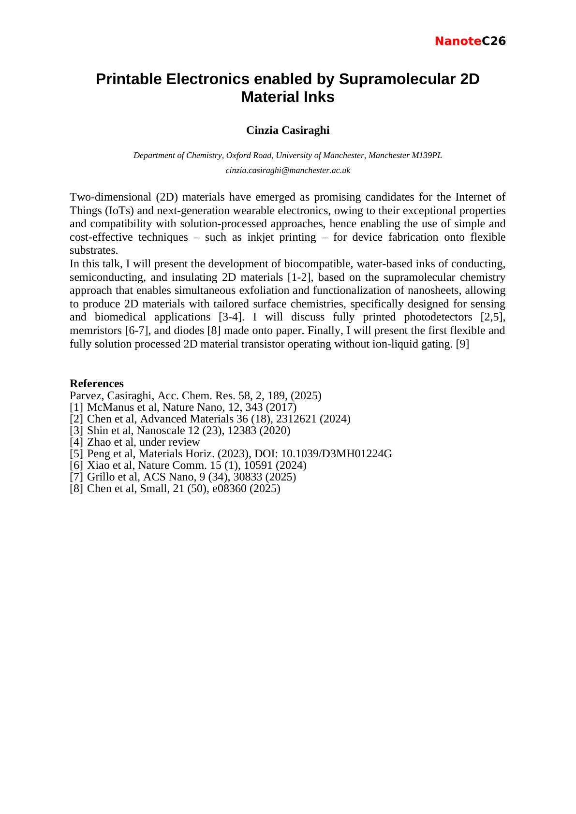

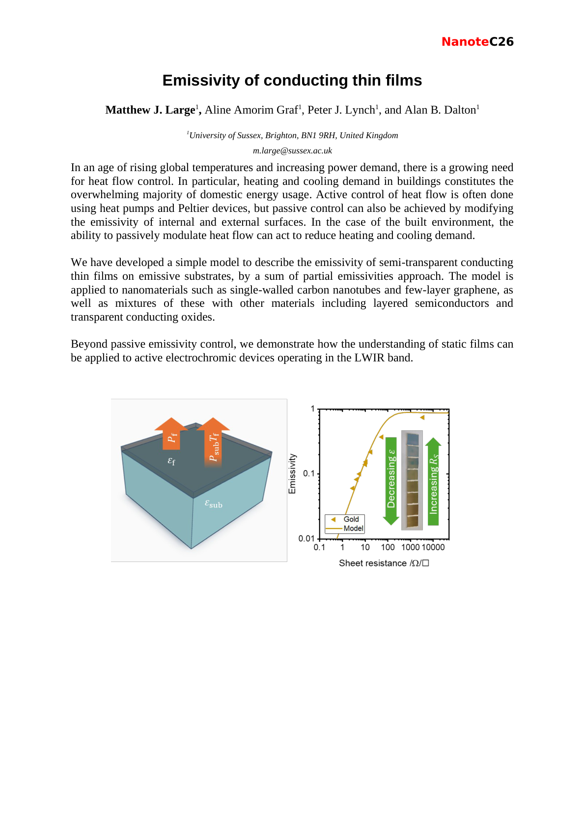

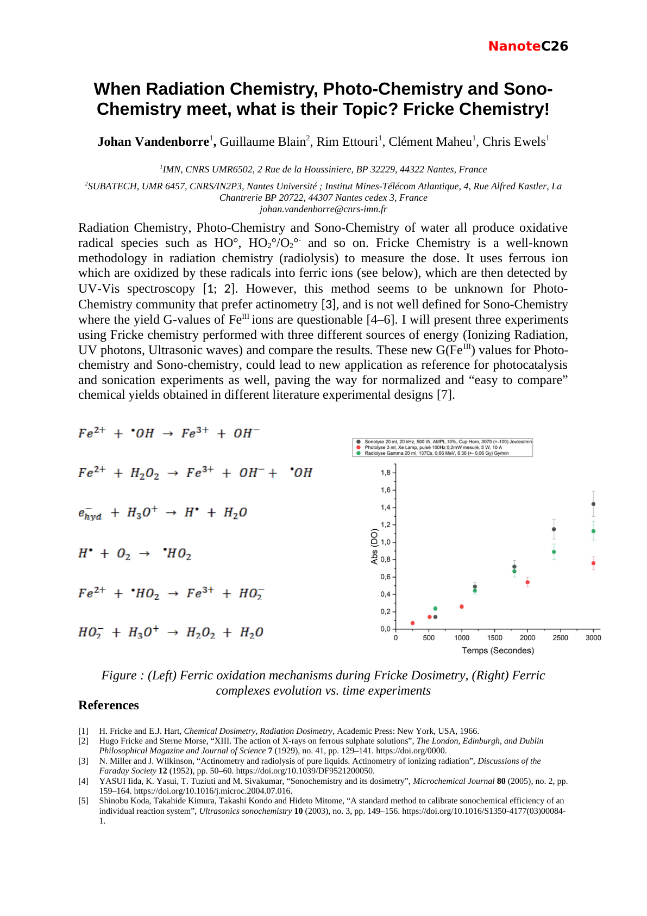



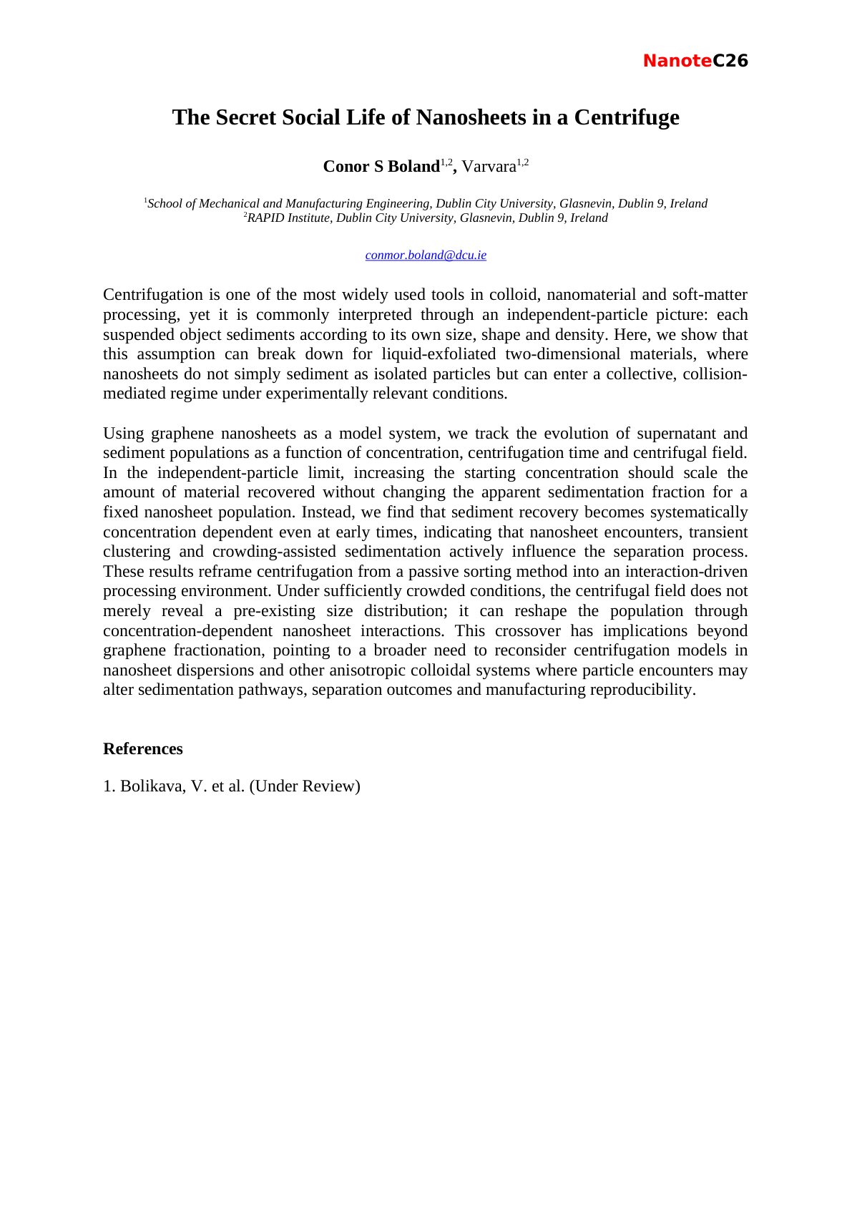

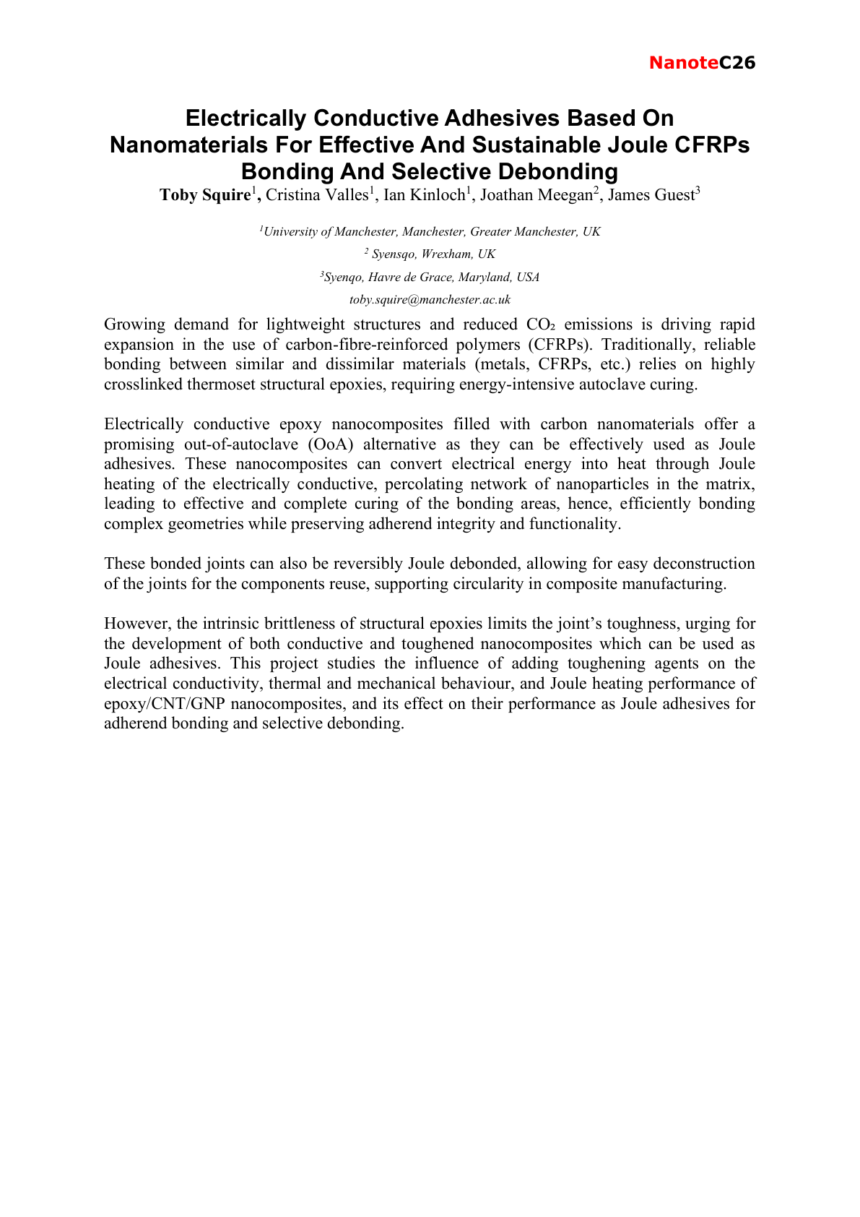

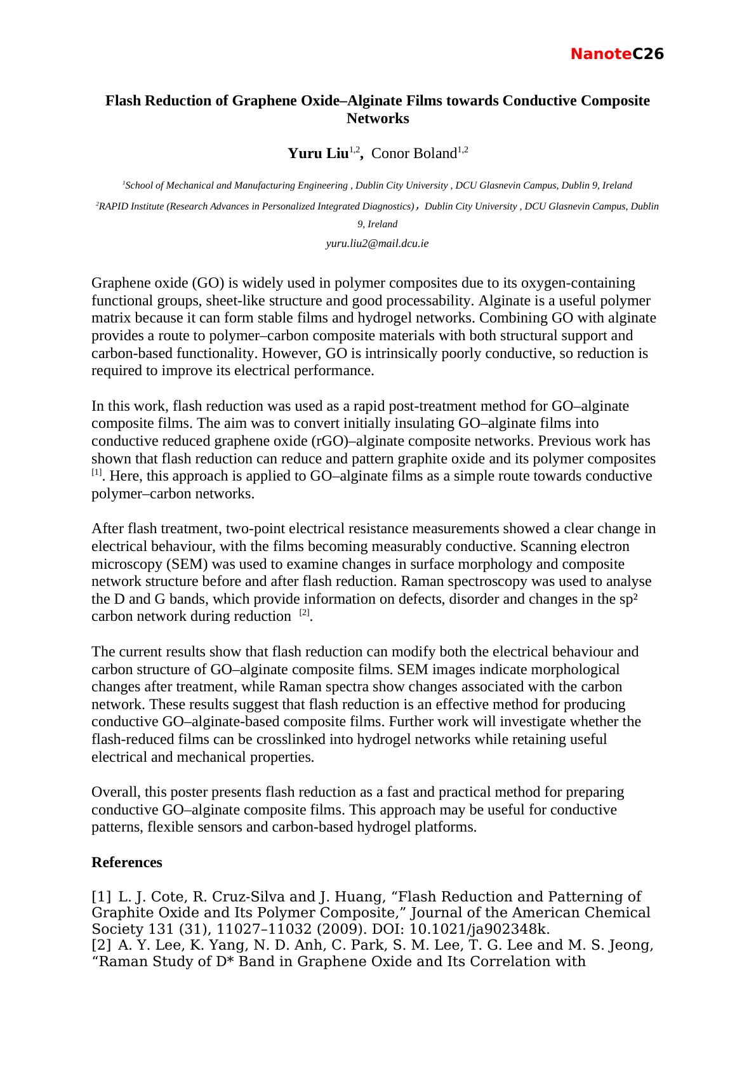



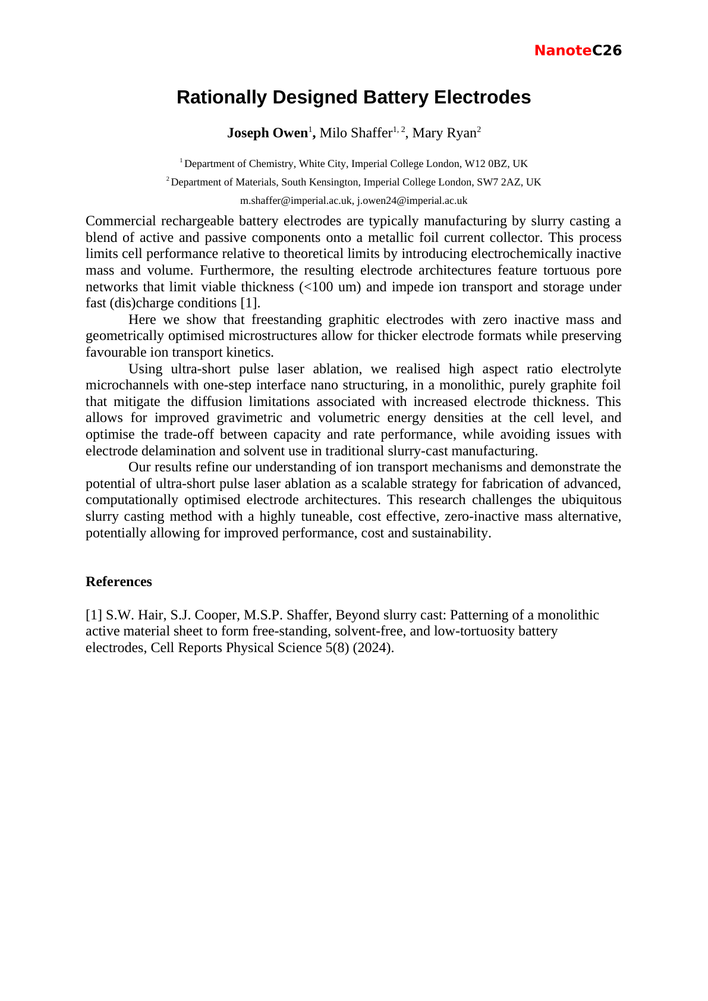

Thursday 3 September 2026
Time | Speaker | Talk title
09:30 | Paola Ayala | Selective enhancement of photoluminescence in hybrids of single-walled carbon nanotubes encapsulating carbyne - NO ABSTRACT AVAILABLE
10:15 | Rebekah Wells | Tailoring the Opto-Electronic Properties in Networks of TMD Nanosheets using Organic Small Molecules
11:10 | Igor Roncevic | A Molecule with Half-Mobius Topology
11:40 | Vjosa Hoda | Optical Properties of TMDC-Based Hetero-Nanotubes
12:00 | Shixin Liu | Scalable and flexible light-emitting diodes based on colloidal 2D semiconductors
14:00 | Natalia Martsinovich | Understanding the effects of defects and dopants on the optoelectronic properties of graphene quantum dots: a theoretical study
14:30 | Ehsan Elahi | Van der Waals Junction Engineering in 2D Chalcogenides: From Broadband Photodiodes to Quantum Transport
14:50 | Xue Li | Polarization-Driven Quantum Confinement at Ferroelectric Domain Boundaries in van der Waals TMDs
15:10 | Patricia Scully | Laser Functionalisation of Polymers for Medical Sensing: 3D Subsurface Carbon Structures
16:00 | Shayan Seyedin | MXene Yarn Asymmetric Supercapacitors for Powering Future Wearable Technology
16:20 | Sean Ogilvie | Interfacial Assembly of Liquid-Exfoliated Nanosheets
Abstracts follow in the same running order.

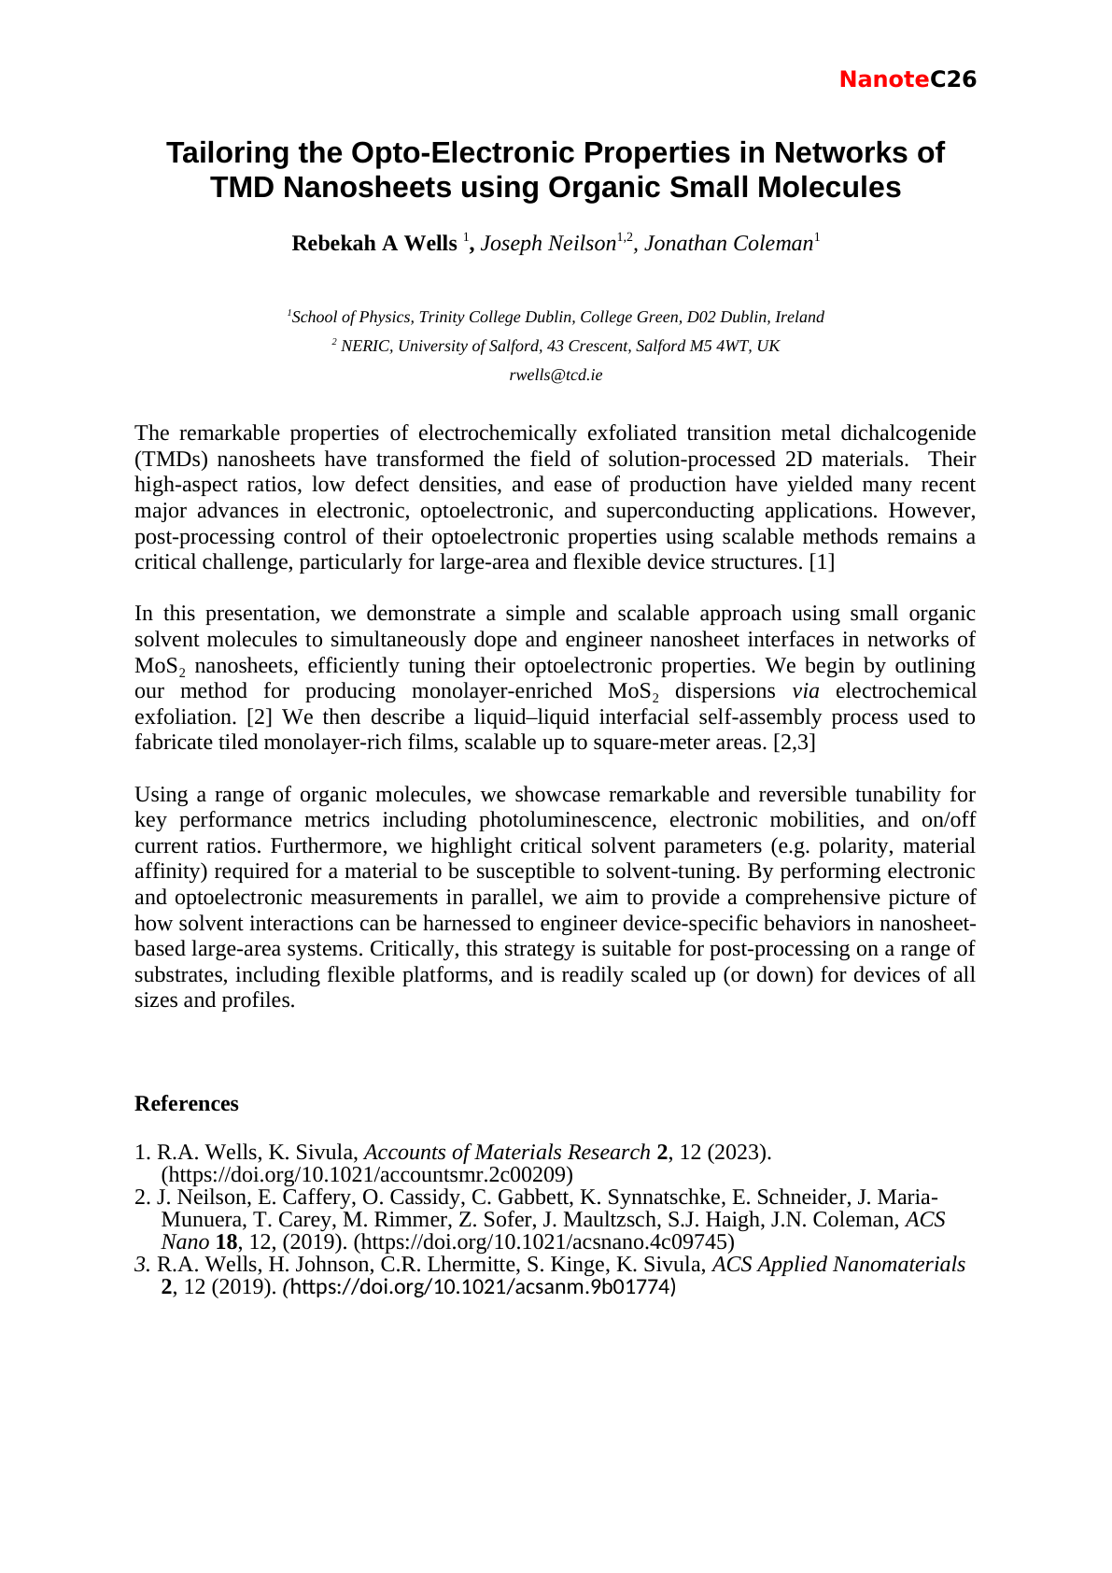

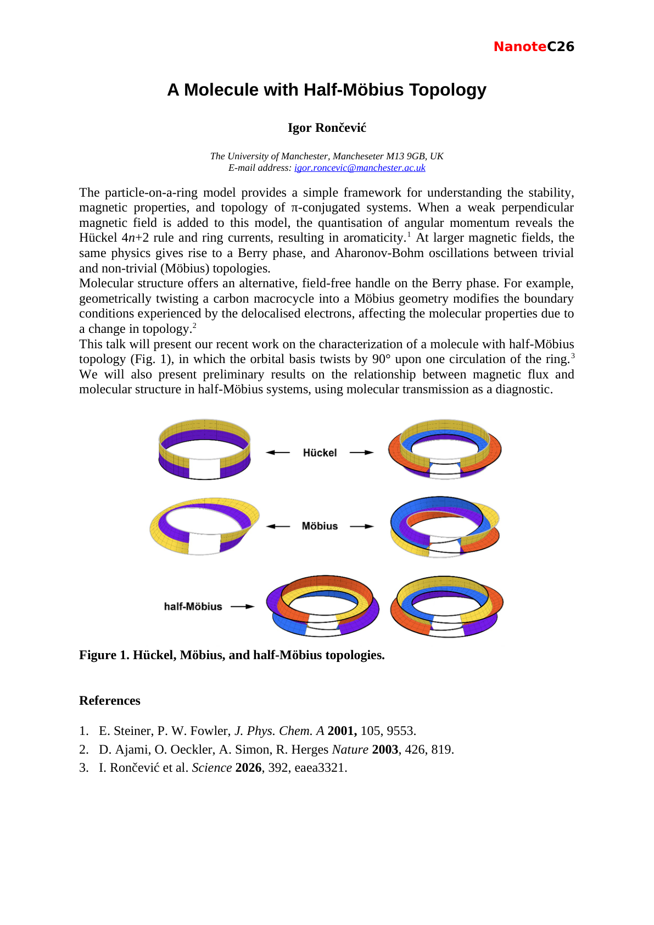

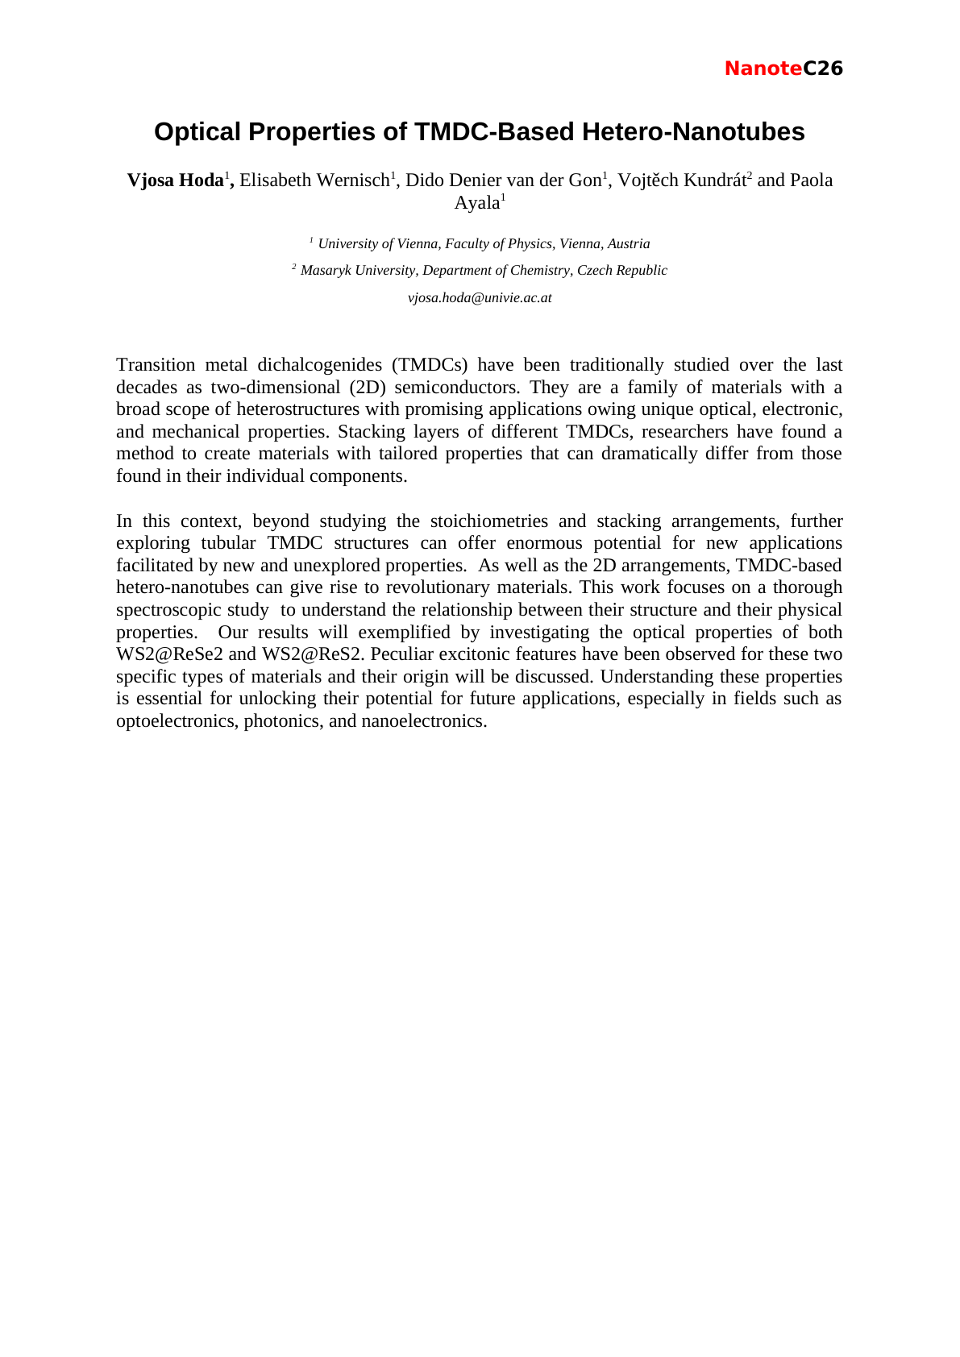

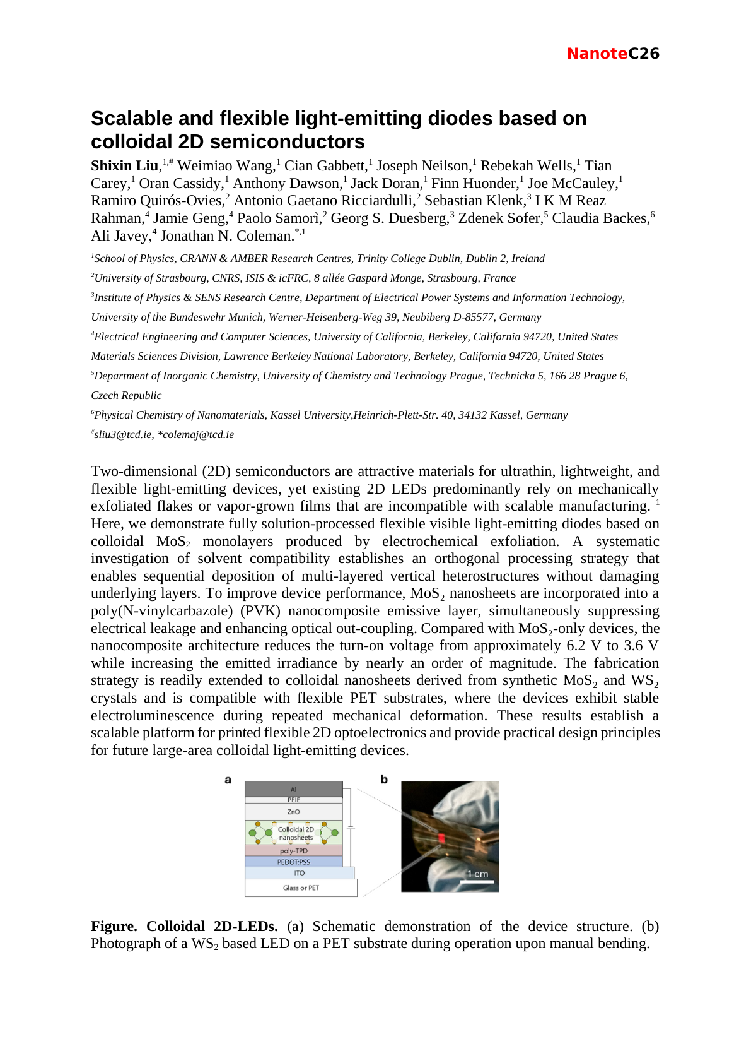



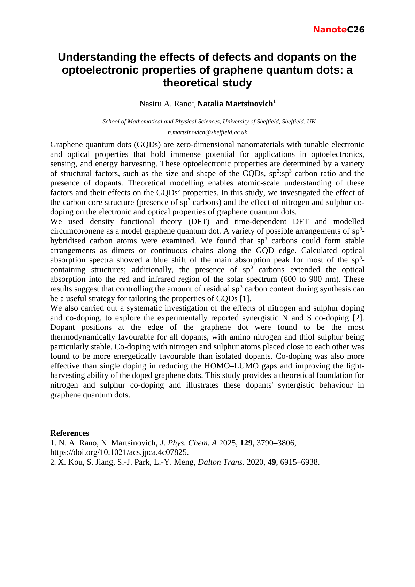

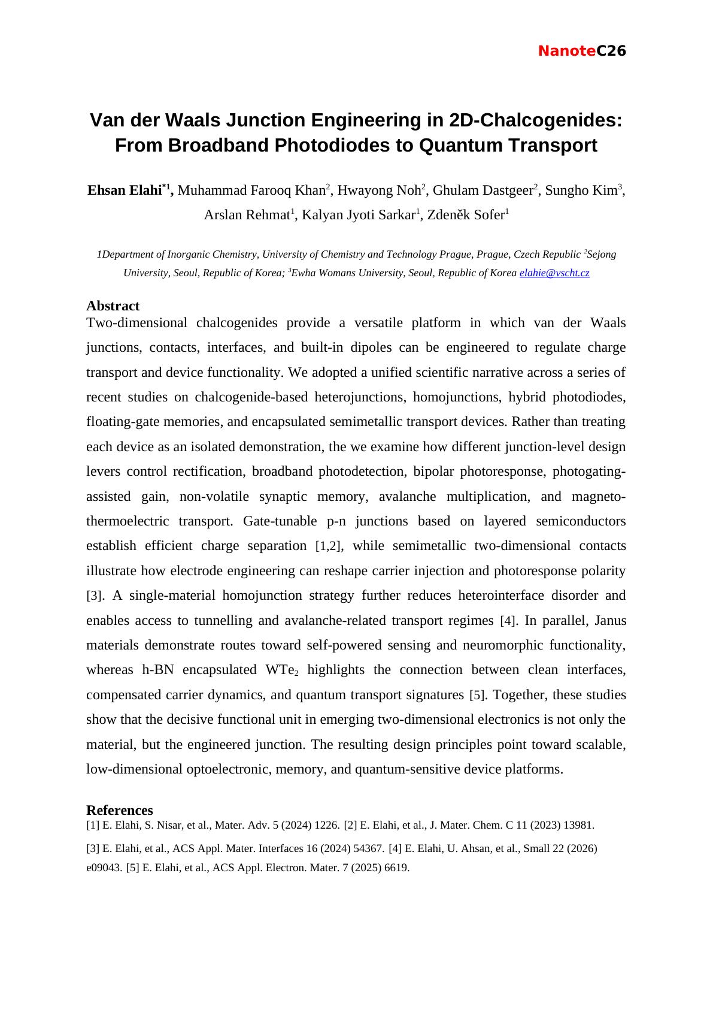

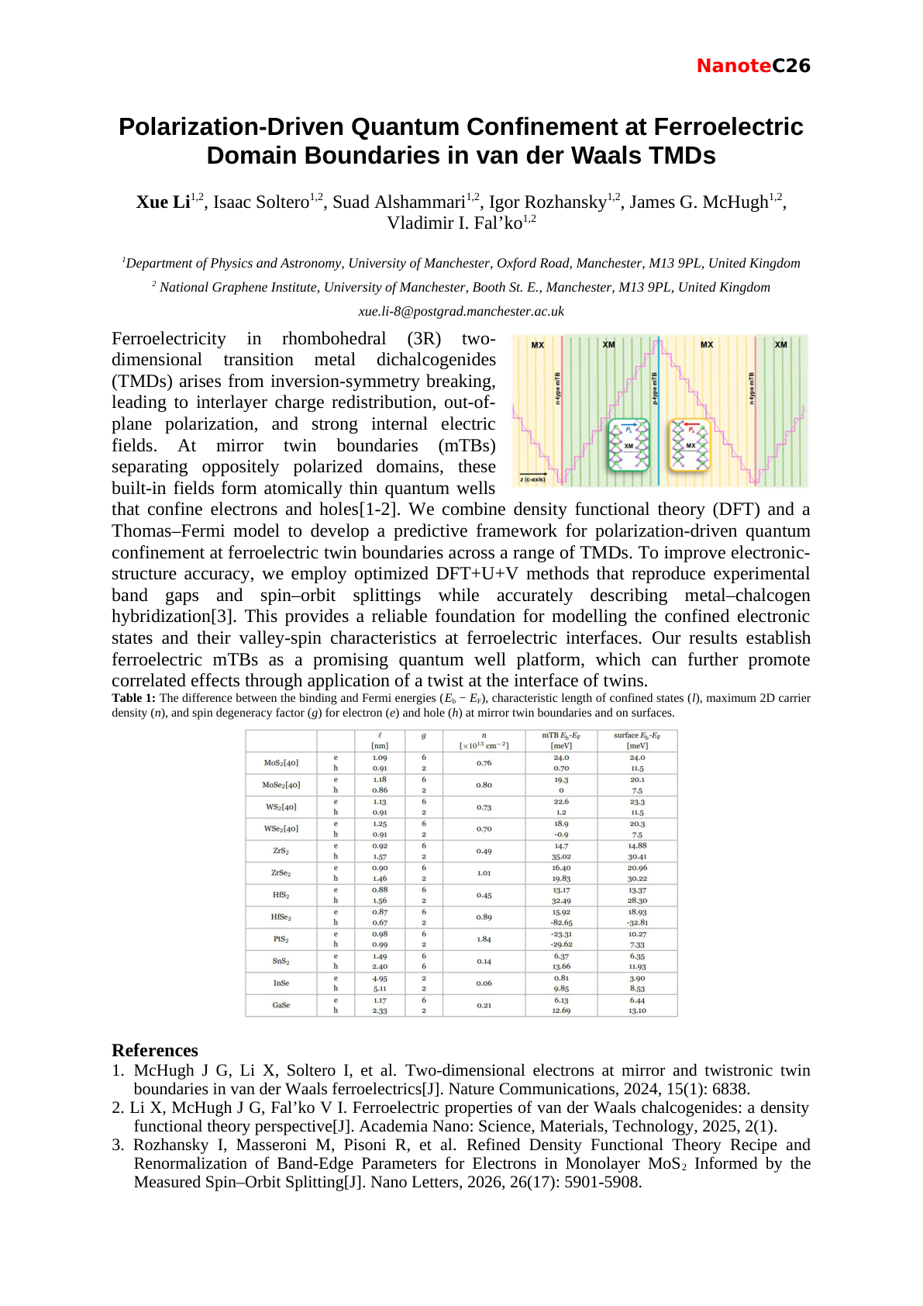

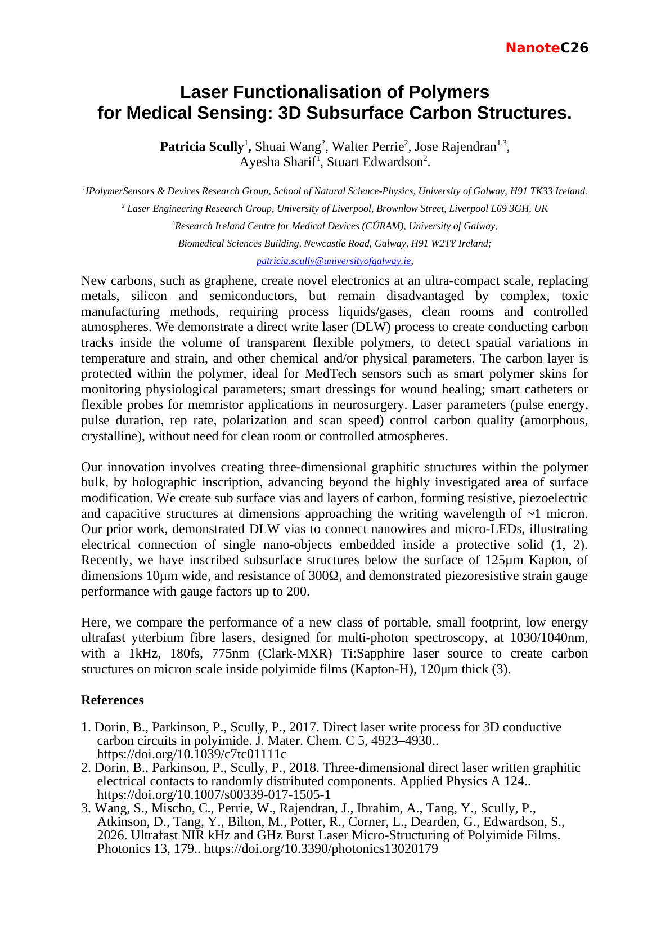

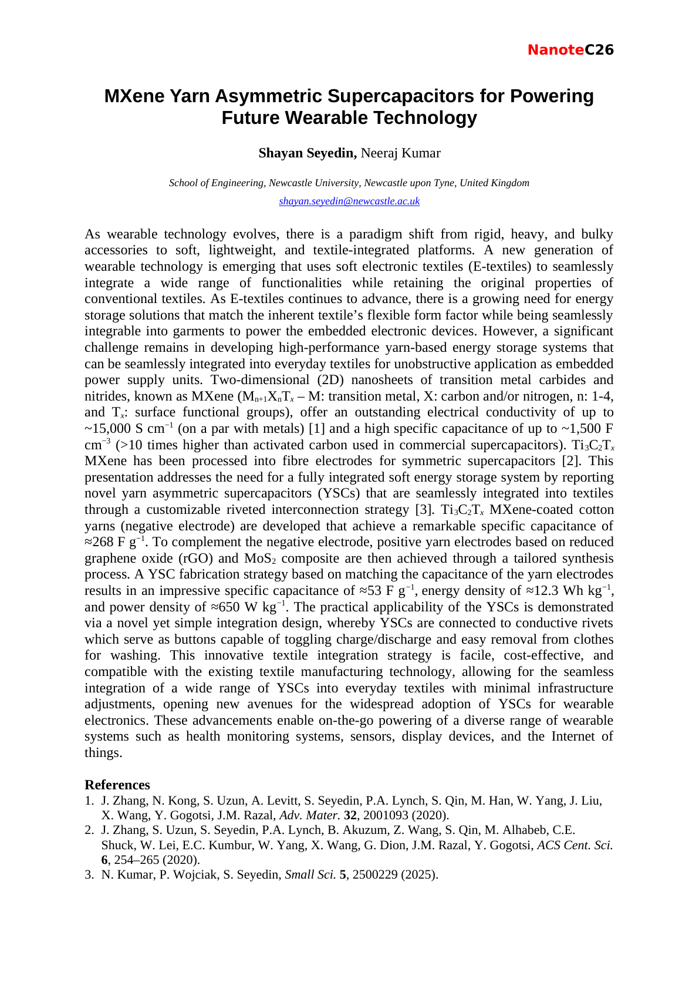

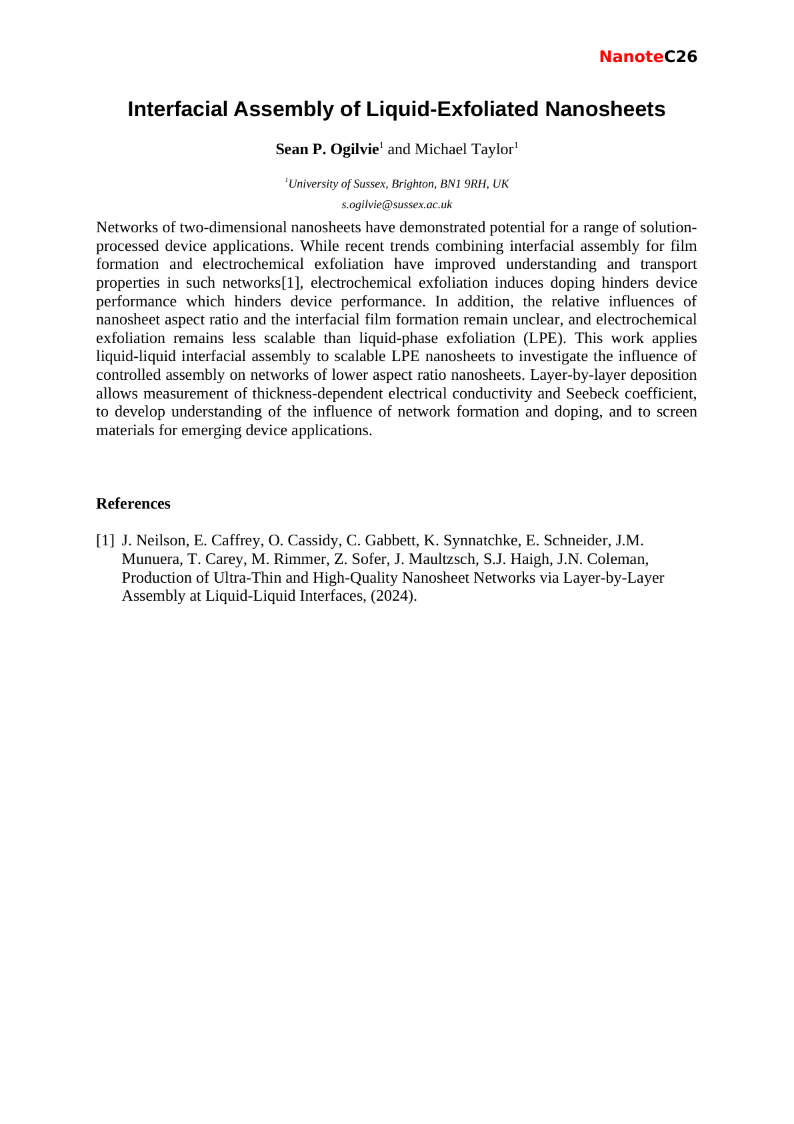

Friday 4 September 2026
Time | Speaker | Talk title
09:30 | Hannah Wood | High throughput kinetic insights into carbon nanotube properties
10:15 | Enny Tran | Thermal conversion of lignin in sustainable carbon fibres spun from a low-cost ionic liquid
10:25 | Ashish Kumar Rajayan | Lignin-Stabilized Nanocarbon Dispersions: From Sustainable Conductive Inks to Flow Electrochemical Energy Storage
11:15 | David J. Lewis | TBC - NO ABSTRACT AVAILABLE
11:45 | Indrajit Maity | Breathing phonons reveal exciton multipolarity in van der Waals heterostructures
12:05 | Mounika Packirisamy | Sustainable Biomass-Derived Activated Carbon/PEDOT:PSS Composite Ink for Seamless Printing of Flexible Micro-Supercapacitors
Abstracts follow in the same running order.

